Trees trimmed in such a way as to not obstruct visibility  Natural Surveillance  Natural surveillance is the ability of people to see and be seen without the assistance of technology, such as cameras. The rule of thumb is - the more eyes on a property or space, the safer it is.  Landscaping  - Trees should be trimmed at a minimum of 7 feet from the ground. This will allow for increased visibility and fewer opportunities for criminals to hide.  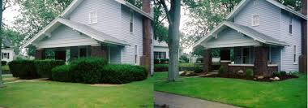  - Shrubbery should be no higher than 3 feet from the ground, especially in front of homes that have first-story windows. This allows clear sight lines from the inside of the residence and limits places for concealment.  Shrubs should be trimmed close to the ground to eliminate hiding spots for thieves and to allow sight lines from the street and inside the home. |  |  | 4. Maintenance  Ongoing commitment to maintenance bolsters a resident’s sense of responsibility, maintains a perception of safety and is a visible sign to all that the property is cared-for.  - Graffiti should be removed immediately  - Trash should be picked up and dumpsters emptied regularly  Maintaining your property with these CPTED principles gives your residents and neighbors piece of mind, reduces crime, increases property values and improves the quality of life in your neighborhood.  - The creators of this publication reserve no rights to the photos used.  - Special thanks to the Connecticut Housing Finance Authority, Portfolio Security  New London Police Dept.  Crime Prevention Unit  5 Gov. Winthrop Blvd.  New London, CT 06320  860-440-6673  rsoccio@ci.new-london.ct.us |  |  | Crime Prevention Guide for Property Owners  - New London Police Department Crime Prevention Unit

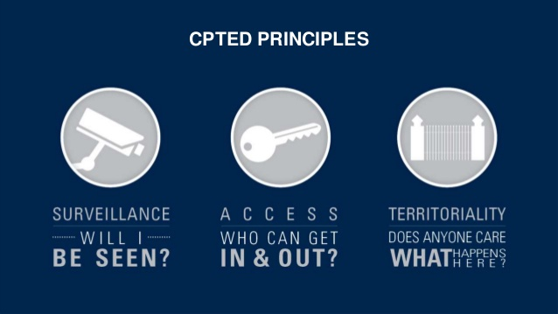  What is CPTED?  Crime Prevention Through Environmental Design  More commonly referred to as CPTED (sep-ted), this is a process by which property owners, architects, public officials, security personnel, property managers and renters all work collaboratively to build and maintain an environment that promotes the legitimate use of a space or property, while minimizing opportunity for crime and unwanted use of that space or property. By designing and maintaining your property in ways that conform to the CPTED principles, you can reduce crime, increase the quality of life for tenants and yourself, and increase safety in your neighborhood.  CPTED can be broken down into 4 components:  1. Natural Surveillance  2. Territory Reinforcement  3. Access Control  4. Maintenance |  |  | Lighting  White, LED lighting that is downward-focused is best for deterring crime. Avoid yellow flood or high-pressure sodium bulbs that contribute to light pollution and distort colors and shapes. Light fixtures should project light downward to avoid light trespass. Choke points such as alleys and doorways should be sufficiently lit as well.  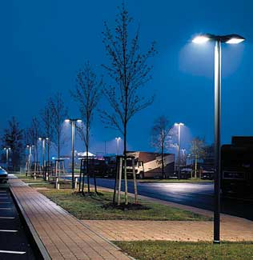  Territory Reinforcement  Territoriality or territory reinforcement tells visitors and passersby that they are transitioning from a public to a private, controlled space. People who are entering should know that this is private property and is managed and maintained by someone. Things such as “No Trespassing” signs or cameras delineate a private space, not public property.  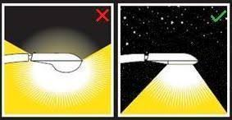  Signs should be posted conspicuously |  |  | Access Control  Fencing / Walls  Effective fencing not only assists with controlling access to your property, but also identifies your property as “owned” space. Chain link fence may be cost effective, but it’s easy to climb-over. Solid fencing may be adequate to delineate property lines and provide privacy, but it also limits visibility from either side. Low picket fencing may be preferable to walls, due to the attractiveness that walls provide to sit on, which may entice trespassing and be undesirable. The ideal form of fencing is metal or iron fencing with pointed tips, at least 6’ high. This provides visibility, aesthetics, enhances security and prevents scaling.  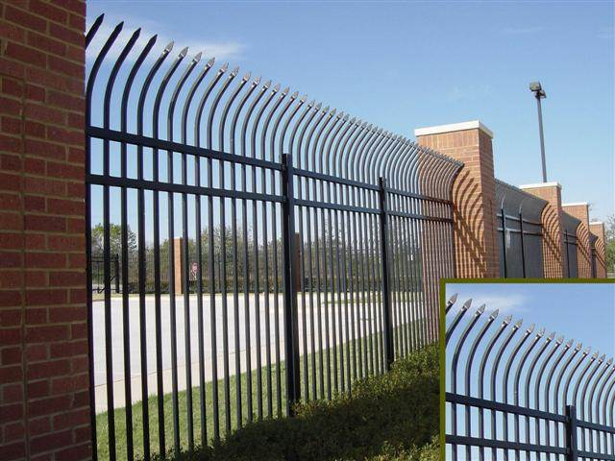  See-through Iron or metal fencing with pointed tips is best for preventing scaling and security while maintaining visibility.  Doors / Locks  Doors should be of solid construction and equipped with at least a 1” deadbolt and fastened with 3” or larger screws, into a wooden frame.

